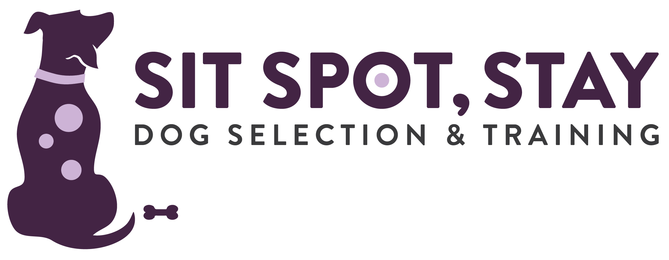

Dog Training Services Agreement

This Agreement between _______________________________ (hereinafter referred to as “Client”) and SIT SPOT, STAY. LLC (hereinafter known as “Trainer”) pertains to the following:

Client’s Dog (Name): ____________________
Breed: ________________________________
Age: __________________________________
Color:_________________________________
(hereinafter referred to as “Dog”)

For good and valuable consideration, the parties agree as follows:

Training Fees:
Client agrees to pay Trainer a nonrefundable fee in the amount of $________ for a package of _____ sessions (approximate length ____________ each) to be paid before the first session. All sessions must be completed within 180 days from the date of commencement of contract or they will be forfeited.

Services: Trainer agrees to provide private lessons for Client and Dog on a lesson-by-lesson basis, the goal being to teach Client how to train and work with Dog. These lessons will take place at Client's home or public place. Trainer will make every reasonable effort to help Client achieve training and behavior modification goals but makes no guarantee of Dog’s performance or behavior as a result of providing professional animal behavior consultation. Client understands that he/she and members of the household must follow Trainer’s instructions without modification, work with dog daily as recommended, and constantly reinforce training being given to Dog. Client understands that because service will be completed in their home, services may begin up to ten (10) minutes before or after the designated time to allow for Trainer travel.

SIT SPOT, STAY. LLC would like to use pictures and/or videos for training and marketing purposes on their website and/or Facebook page. Please initial following below:
___ I agree that pictures or videos of my dog(s) may be used on the SIT SPOT, STAY. LLC website or Facebook page.
___ I DO NOT agree that pictures or videos of my dog(s) may be used on the SIT SPOT, STAY. LLC website or Facebook page.

Cancellation Policy: If Client fails to give at least 24 hours cancellation notice, or is not present at time of scheduled appointment, session fees are still due. For a package deal, the session will still be counted as one session.

Liability: If Dog causes property damage, or bites or injures any dog, animal or person (including but not limited to Trainer and Trainer’s agents), or causes any other liability during or after the term of this Agreement, then Client on behalf of any and all participants authorized or permitted to attend any lessons or review training suggestions or articles, agrees to defend, indemnify and hold harmless Jamie Burns and SIT SPOT, STAY. LLC and agrees to pay all resulting losses and damages suffered or incurred, and to defend and indemnify Trainer and Trainer’s agents from any resulting claims, demands, lawsuits, losses, costs or expenses, including attorney fees. If Dog is injured in a fight or in any other manner during or after the term of the Agreement, Client assumes the risk and agrees that Trainer should not be held responsible for any resulting injuries, losses, damages, costs or expenses. Client acknowledges that the Dog’s behavior now and in the future is solely Client’s responsibility.

Client also understands that SIT SPOT, STAY. LLC is relying on their representation that Dog is up to date on all immunizations required or recommended by the State of Indiana, Hamilton, Marion and Boone Counties and their veterinarian, this includes, but is not limited to a rabies vaccination.

Client takes upon themselves to ask questions and use Client’s own common sense. Client understands that Client does not have to do anything or allow anything to be done that Client is not comfortable with.

At Trainer's sole election, Trainer's duties hereunder shall terminate if (a) in Trainer's sole judgment Dog is dangerous or vicious to Trainer or any other person or animal, or interferes with the training of other dogs, or (b) Client breaches any term or condition of this Agreement. Upon termination in accordance with the foregoing, Trainer's duties shall terminate but all other provisions of this Agreement shall continue in full force and effect.

This Agreement is binding upon Client, spouse of Client, children of Client and any residents or visitors of the Clients home where training occurs. This Agreement supersedes all prior discussions, representations, warranties and agreements of the parties, and expresses the entire agreement between Client and Trainer regarding the matters described above.

The parties confirm that, except for that which is specifically written in this Agreement, no promises, representations or oral understandings have been made with regard to Dog or anything else. Without limiting the generality of the foregoing, Client acknowledges that Trainer has not represented, promised, guaranteed or warranted that Dog will never bite, that Dog will not be dangerous or vicious in the future, that Dog will not exhibit other behavioral problems, or that the results of the training will last for any particular amount of time. This Agreement may be amended only by a written instrument signed by both Client and Trainer.

Executed on this _________ day of _______________________, 20____

Trainer: Client:
______________________ ______________________________

(signature) (signature)

Jamie Burns, Dog Trainer ______________________________

(print name)

